Title (Heading 1 Style)
Author Name(s) - leave blank for double-blind, peer-review process
Body of publication (Normal Style).
NOTE: open the Styles Pane above in the main menu ribbon under the Home tab so it appears to the right and you can see the style being applied
NOTE: all content is left-aligned

Subtitle (Heading 2 Style)
Body of publication (Normal Style).
Use superscript numbering for in-text citations.^{2,3}
For numbered lists (List Paragraph Numbered Style).
- First list item
- Second list item
For bulleted lists (List Paragraph Bulleted Style).
- First list item
- Second list item

Subheading (Heading 3 Style)
Body of publication (Normal Style).
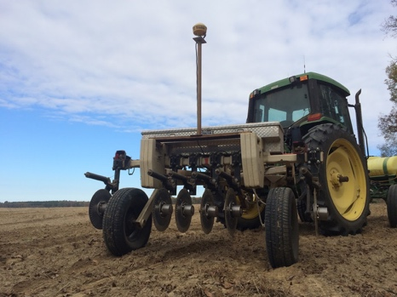
Figure 1. Caption. Image credit: name, affiliation.
NOTE: for images (1) use Insert or Paste to add images; do NOT create text boxes and place images inside; (2) select Wrap Text, select Top and Bottom; (3) right-click image and add alt text
NOTE: for image captions (1) right-click image, (2) select Insert Caption, (3) select figure option and type in caption, (4) caption appears below image with font formatted for Caption Style; (5) bold Figure #.
Table 1. Caption.
Sample Table | Use Arial 9 font | Bold Headings | Headings
Use Arial 9 font for content of cells | Do not use any shading | Add alt text, by selecting the table, select properties, alt text | Fit table to page by selecting table, AutoFit and Distribute, AutoFit to Window
Left align table | Left align all table content

NOTE: for table captions, (1) right-click image, (2) select Insert Caption, (3) select table option and type in caption, (4) caption appears above table with font formatted for Caption Style; (5) bold Table #.

References Cited (Heading 2 Style)
NOTE: for list below, apply Bibliography Style
- Author Last Name (no punctuation) First Name Initial(s), Author Last Name (no punctuation) First Name Initial(s). Article title (use sentence case). Journal Name (use title case). Year Month-1st-three-letters;Volume(Issue):page numbers.
- Doe J, Johnson A. This is the title of the publication. Journal Name. 2019 Mar;10(1):58–72.

NOTE: the Extension statement is included at the very end of the publication
Clemson University Cooperative Extension Service offers its programs to people of all ages, regardless of race, color, gender, religion, national origin, disability, political beliefs, sexual orientation, gender identity, marital or family status and is an equal opportunity employer.
The information in this publication is provided for educational and informational purposes only. The use of any brand names and any mention or listing of commercial products or services in this publication does not imply endorsement by Clemson University nor does it imply discrimination against similar products or services not mentioned. Recommendations for the use of agricultural chemicals may be included in this publication as a convenience to the reader. Individuals who use agricultural chemicals are responsible for ensuring that their intended use of the chemical complies with current regulations and conforms to the product label.
This publication may be reprinted in its entirety for distribution for educational and informational purposes only. Any reference made from this publication must use the provided citation.

